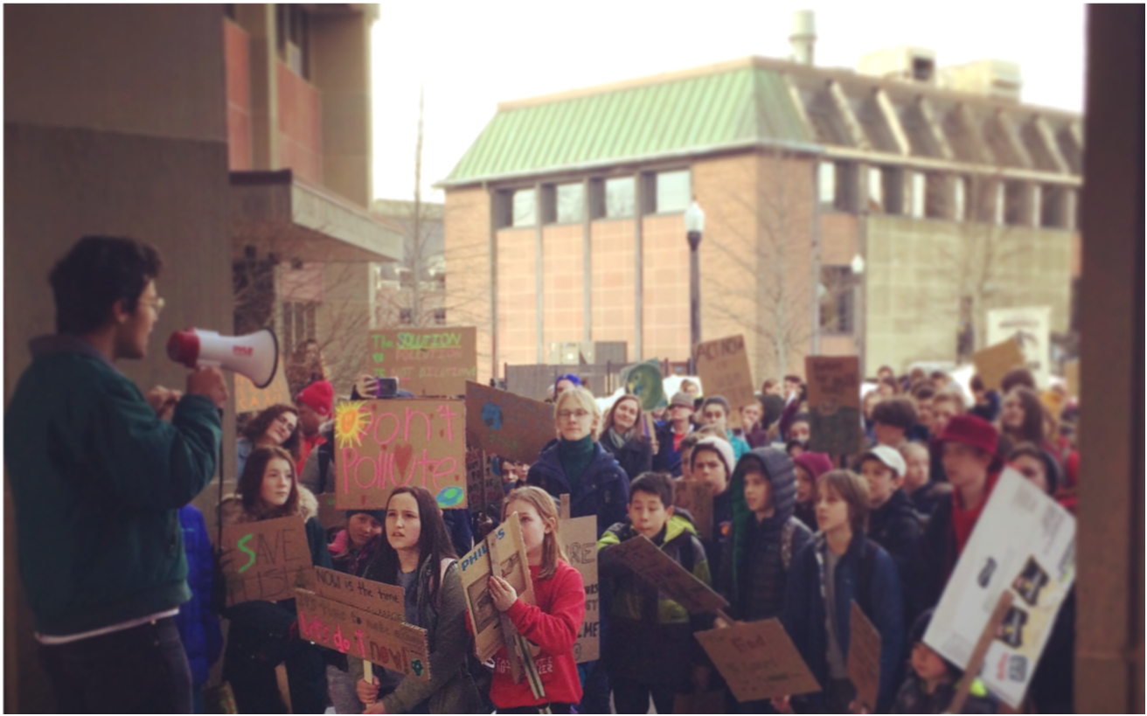
 | What’s happening May 3rd? | Students across Canada are striking from school to demand action on climate change. (See below for details of the Sackville strike.)
 | But there’s no school on May 3rd! | In Sackville and surrounding areas, students do not have school on Friday, May 3rd. And yet, they are still organizing to bring attention to our climate emergency! This is part of a Canada-wide strike, standing together with students across the country, many of whom will leave classes to participate.
 | Who is organizing the strike? | Students in Sackville are taking the lead to organize the May 3rd strike, as they did for the March 15th strike. Students from Mount Allison University, Marshview Middle, and Tantramar Regional High Schools are the main organizers. Fridays for Future Canada is helping connect the student strikes across the country.
 | How did this get started? | In August 2018, a Swedish teenager named Greta Thunberg started striking from school every Friday in front of the Swedish Parliament. Her actions have turned into a global movement!
 | What has been done so far? | On March 15th, Sackville youth organized a student climate strike as part of a global day of action with Fridays for Future. They demanded specific and sweeping actions from municipal, provincial, and federal governments. Some actions have since been taken by municipal government and by our provincial MLA.
 | What are the students asking for? | The students are asking adults to wake up to the realities of climate change and to take immediate action now! On May 3rd, students will be sending postcards to the federal government to demand action on climate change.
 | How can non-students help? | The climate strike is open to everybody! Show your solidarity – and your commitment to action – by marching alongside students on May 3rd. You can also help spread word about the climate strike, so that everybody knows about it and what it’s for.
FAQ’s
Find out more at sycc.org.
Sackville Climate Strike - May 3rd
Sackville Climate Strike
Friday, May 3rd
1:00pm – Rally and poster/postcard making at the Sackville Commons (64 Main Street)
2:30-3:30pm – March from the Commons through town to the post office and back to the Commons
3:30-4:00pm – Wrap-up at the Commons

